A. Table Understanding
SELECT * FROM orders LIMIT 10;
SELECT * FROM customers LIMIT 10;
SELECT * FROM products LIMIT 10;

B. Data Cleaning
1. Check NULL values :
SELECT * FROM orders
WHERE customer_id IS NULL OR product_id IS NULL;

2. Remove duplicates :
SELECT product_id, COUNT(*)
FROM products
GROUP BY product_id
HAVING COUNT (*)>1 ;

C. Data Joining
SELECT o.order_id, o.order_date,
c.customer_name, o.sales
FROM orders o
JOIN customers c ON o.customer_id = c.customer_id
JOIN products p ON o.product_id = p.product_id;
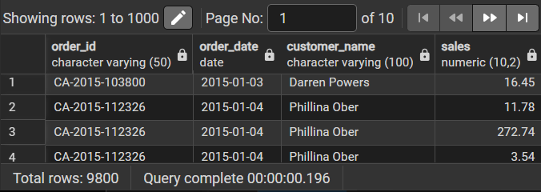

A. KPI’s
1. Total Sales :
SELECT SUM(sales) AS Total_Sales
FROM orders;
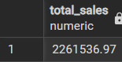
2. Total Customers :
SELECT COUNT(DISTINCT Customer_id) AS Total_Customers
FROM Orders;
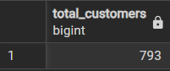
3. Total Orders :
SELECT COUNT(Order_id) AS Total_orders
FROM Orders;
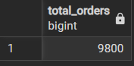
4. Average Order Value :
WITH order_totals AS
(SELECT order_id, SUM(sales) AS total_order_value
FROM orders
GROUP BY order_id)
SELECT AVG(total_order_value) AS average_order_value
FROM order_totals;
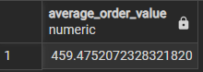

B. Business Analysis Queries
1. Sales Trend :
SELECT DATE_TRUNC('month', order_date) AS month,
SUM(sales) AS total_sales FROM orders
GROUP BY month
ORDER BY month;
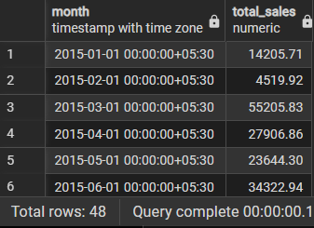
2. Top Customers :
SELECT c.customer_name, SUM(o.sales) AS total_sales
FROM orders o
JOIN customers c ON o.customer_id = c.customer_id
GROUP BY c.customer_name
ORDER BY total_sales DESC
LIMIT 5;
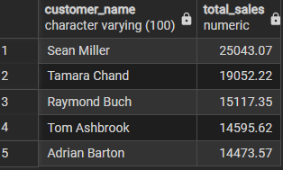

3.Category Performance :
SELECT p.category, SUM(o.sales) AS total_sales,
FROM orders o
JOIN products p ON o.product_id = p.product_id
GROUP BY p.category;
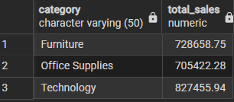
4. Customer Retention :
SELECT customer_id,
COUNT(DISTINCT DATE_TRUNC('month', order_date)) AS active_months
FROM orders
GROUP BY customer_id
HAVING COUNT(DISTINCT DATE_TRUNC('month', order_date)) > 1;
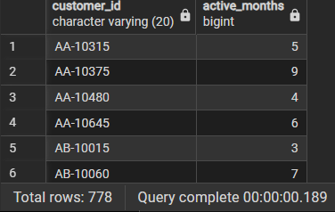
5. Contribution Analysis :
SELECT product_id, SUM(sales) AS total_sales,
ROUND(SUM(sales) * 100.0 / SUM(SUM(sales)) OVER (), 2) AS contribution_pct
FROM orders
GROUP BY product_id;
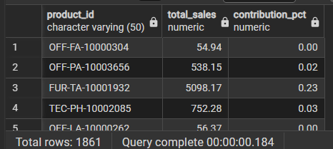
6. Ranking :
SELECT customer_id,
SUM(sales) AS total_sales,
RANK() OVER (ORDER BY SUM(sales) DESC) AS rank
FROM orders
GROUP BY customer_id;
